Can you find all the dinosaurs and break the CODE? (Recommended ages 8 and up.)

**Find all 4 herds of dinosaurs hidden in the Children’s Department, and solve the secret message on the next page. You may ask a librarian where different book sections are and help with the pigpen cipher if needed!**

* Herd 1 is in the picture book area. Find all 9 dinosaurs and write all 9 letters here: (You can unscramble them now or later.)

___ ___ ___ ___ ___ ___ ___ ___ ___

* Herd 2 is in the non-fiction section, right by our books about dinosaur facts. Write all 7 letters here: (You can unscramble them now or later.)

___ ___ ___ ___ ___ ___ ___

* Herd 3 is in the fiction section. Use the **pigpen cipher** to turn the symbols into letters. After you decode the secret word, write the word here:

___ ___ ___ ___ ___

* Herd 4 is in the biography section. Use the **pigpen cipher** to turn the symbols into letters. After you decode the secret word, write the word here:

___ ___ ___ ___

Pigpen Cipher

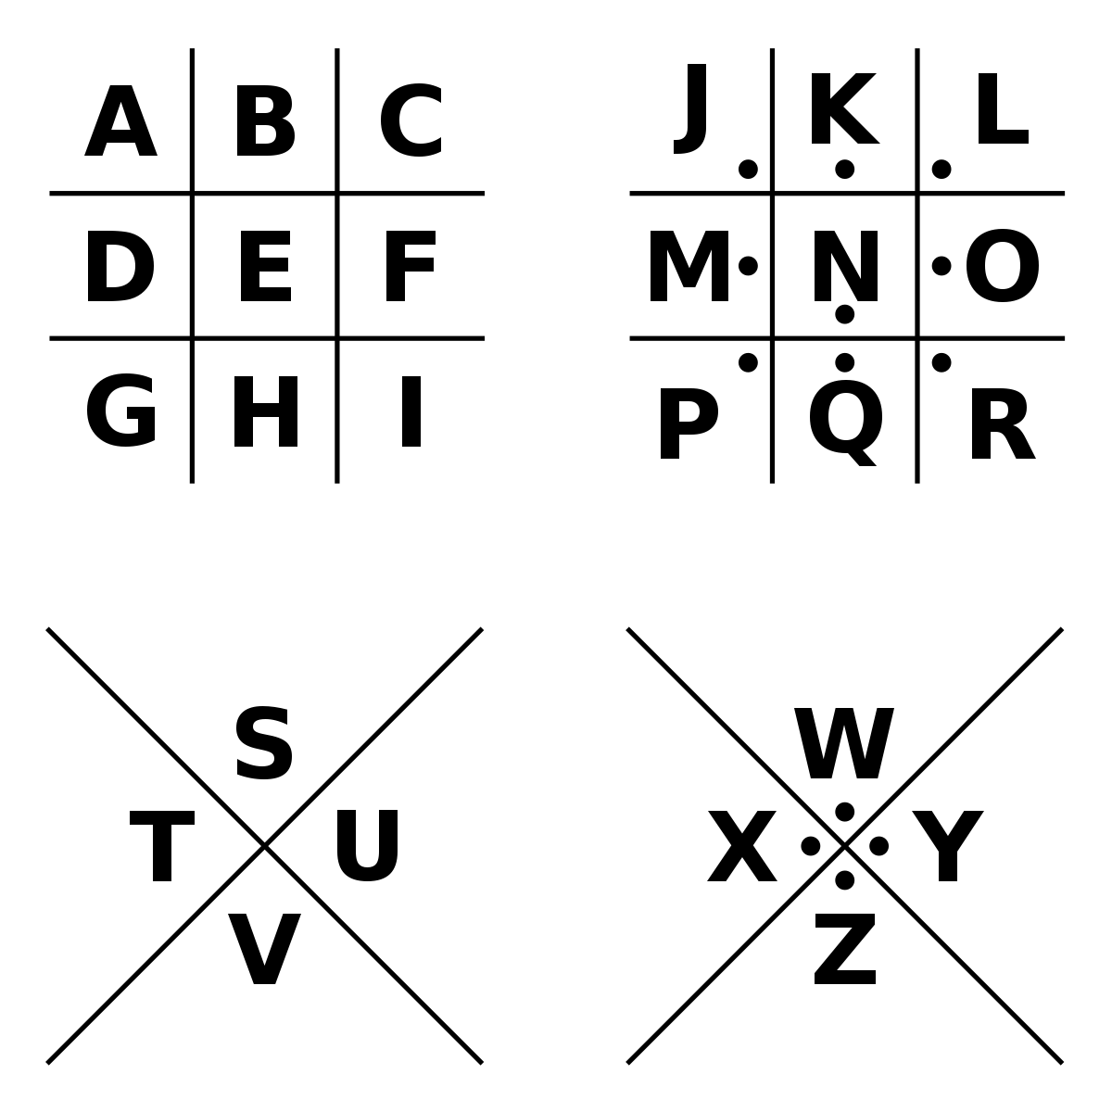

Each letter is represented by the lines and dots around it, like the letter is a pig in a pen. Practice writing your name below in Pigpen Cipher:

Can you find all the dinosaurs and break the CODE? (Recommended ages 5 to 7 with help from an adult.)

* Herd 1 is in the picture book area. Find all 9 dinosaurs and write all 9 letters here: (You can unscramble them now or later.)

*Hint: The word begins with the letter “D”.*

___ ___ ___ ___ ___ ___ ___ ___ ___

* Herd 2 is in the non-fiction section, right by our books about dinosaur facts. Write all 7 letters here: (You can unscramble them now or later.)

*Hint: The word begins with the letter “E”.*

___ ___ ___ ___ ___ ___ ___

***Complete the sentence below using the words that you found!***

write the

Did you know that some __________________

write the 1st word that you found here

had feathers? The ________________

write the 2nd word that you found here

that you see today evolved from small, feathered

word that you

dinosaurs that ate meat!

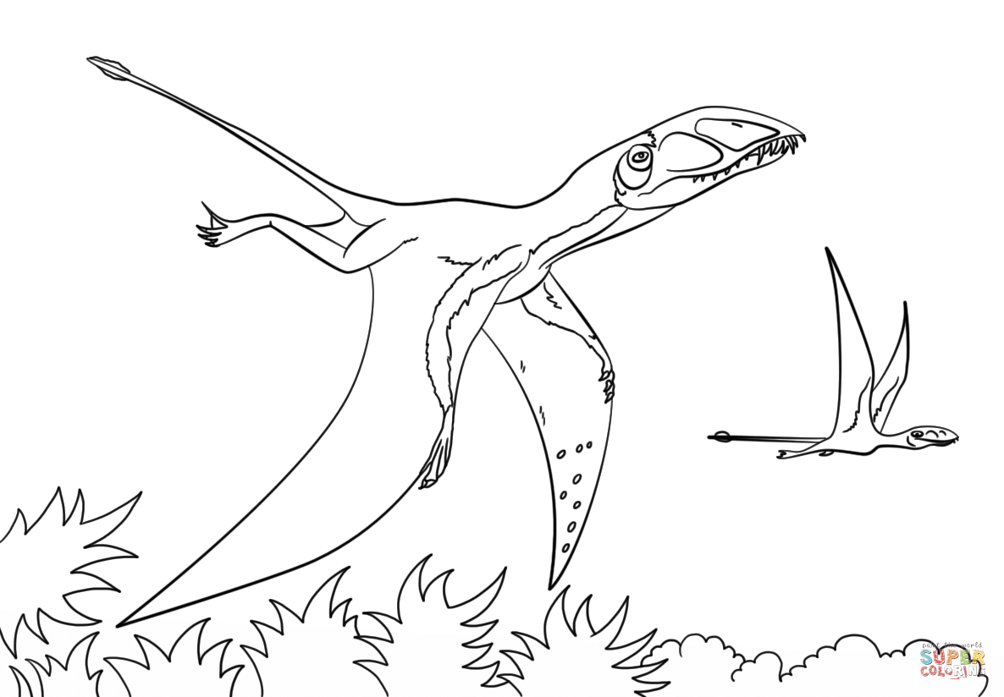

**Dimorphodon**

**Pterodactylus**

**Hybodus**

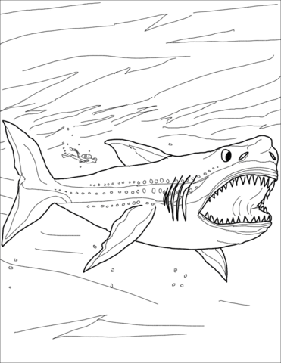

**Megalodon**

13 Living Creatures that

Existed Alongside Dinosaurs

**Crocodiles** **Snakes**

## Bees Horseshoe Crabs

## Sharks Lobsters

## Sea Stars Green Sea Turtles

## Duck-Billed Platypuses Tuatara

## Octopus Cockroaches

## Jellyfish

## 

## **3 Fun Facts:**

## · The tuatara is a reptile found in New Zealand. It looks a lot like a lizard, but it’s not.

## · Cockroaches were TWICE as big before the dinosaurs came around.

## · The oldest octopus fossil shows that they existed long before the dinosaurs and had 10 tentacles instead of 8 with 2 rows of suckers instead of just 1!